EASY READ PRIVACY

WHAT DO YOU KNOW ABOUT THE PRIVACY OF YOUR INFORMATION?

 | This Document is about Your Privacy
We store information like;

- Your child’s name, address and phone number
- People who are important in your child’s life (mum, grandma, family friend…etc.)
- Details about why and how we are helping your child

 | This helps us to support you, and to check the quality of our services. We are responsible for keeping your child’s information safe.
 | We use your child’s information so we can work with you to design supports to suit your child and family
 | We only share your child’s information if you say ‘Yes’, or if there is a situation that makes us.
We only share your child’s information
- with a trusted person
- when we need to so you can be safe
- with your permission to provide required information to NDIS or other government organisations

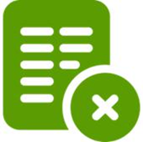 | When asked to share your child’s information you can say ‘No’ or opt-out of sharing it.
 | We keep your child’s information safe so only those you say can see it.
You have several rights with your information:
- The right to see a copy of the information we hold about your child
- The right to have inaccurate or incomplete information corrected by us
- The right to object to any information you think is inaccurate

 | If you want to see your child’s information just ask us.

